Standalone bushfire plan
2025-2026
Frankland River Primary School

Purpose

The Standalone bushfire plan document is a detailed plan of how your school or site is to prepare and respond to the bushfire high-threat period or in the event of a bushfire.

As principal or site manager, you must complete this template to have a plan in place to respond to a bushfire emergency. This plan is to be read in conjunction with information on Ikon to prepare for bushfire season at your school.

All staff, students, contractors and visitors on the school or site are to follow this completed plan in the event of a bushfire emergency. All other emergencies are to be managed in accordance with the school or site’s incident management plan, as per the Incident management manual.

Complete and lodge your plan online by 31 August.

Contents
1. School or site details 3
2. Emergency response contact list 4
2.1 Important bushfire emergency contact sources 5
3. School or site Response Team 6
4. School or site response telephone tree 7
4.1 Residential college response telephone tree 8
5. Emergency equipment 9
6. Bushfire preparation checklist 10
7. Bushfire action plan maps 12
7.1 Onsite ‘safer building location(s)’ 12
7.2 Offsite evacuation locations 13
Appendix A - Bushfire warning stages 14
Appendix B - Procedures in the event of a sudden bushfire 15
Relocate to onsite ‘safer building location’ 15
Offsite evacuation procedures 17
Appendix C - Pre-emptive (planned) school closure procedures 19
Flow chart – Principal’s pre-emptive school closure response 20
Appendix D - After-hours or school holiday procedures 21

- School or site details

To complete this plan, on the front cover of the document:
- insert your school or site name
- add the year for the new bushfire season
- add the date in the footer to show when the plan became active.

Enter information into the grey sections of this document, following the prompts in the square brackets where featured. You can add extra rows to tables where necessary.

When your plan is complete, follow the steps on Ikon to lodge, update or access your standalone bushfire plan online.

School or site details
School or site name  (include name of co-located school or facilities if applicable) | Frankland River Primary School
School or site address | 1 Evans St, Frankland River WA 6396
Education Region | South West
Number of students | 56
Number of students requiring extra support if evacuating | 1
Number of staff | 14
Estimated number of animals on site, if applicable | 0
Estimated number of animals on site that would require evacuation, if applicable | 0
Number of school or site sides bordered by bush | 2
Names of major roads bordering school or site | 3  Evans St, Moir St, Trent St
School or site’s site-specific alert, for example:  - siren/pause x 3  - continuous handbell  - continuous siren or short whistle blasts | Continuous siren

Plan prepared by (name) | Bronwyn Morris
Date prepared or reviewed | August 2025

- Emergency response contact list
Dial 000 in an Emergency

Enter the contact details into the following table:

Organisation | Details | Phone number / website
Local police  (for example, name of nearest police station) | Police call centre  Cranbrook Police | 131 444  000  T: 08 6801 3840
Local hospital  (name of nearest hospital or medical emergency facility) | Plantagenet Hospital | 000  T: 9892 1222
Department of Fire and Emergency Services regional contact | Shane Harris (Community Emergency Services Manager) | 000  9826 1008  0499 899 189  shane.harris@cranbrook.wa.gov.au
Local fire brigade  ( always use 000 during an emergency) | Cranbrook Chief Bushfire Control  Graham Marshall  Tom Ettridge | 000  0407 261 005  0427 566 232
Bus contractors  (ready for pre-emptive closure or offsite evacuation) | Kim Haynes (Bokerup)  Leanne Dove (Kybellup)  June Roberts (Rocky Gully) | 0417 374 830  0438 584 514  0407 912 468
Electricity provider - in the case of a power outage  (for example, Horizon Power, Western Power) | Western Power | 13 13 51
State emergency service | State Call Centre  Mount Barker (Duty number) | 13 25 00  0448 511 127
Poisons information (where relevant) |  | 13 11 26
Director of Education name | Dainon Couzic | 0466 573 908

For agricultural colleges and farm schools only:

Contact person or organisation | Details | Phone number / website
Animal technicians

Local veterinarian or 24 hour emergency clinic

2.1 Important bushfire emergency contact sources

DIAL 000 in an emergency

Emergency WA
Website: https://www.emergency.wa.gov.au/

Department of Fire and Emergency Services
Information line: 13 33 37
Website: https://www.dfes.wa.gov.au/
Facebook: https://www.facebook.com/dfeswa
Twitter: https://twitter.com/dfes_wa

ABC Emergency
Website: https://www.abc.net.au/emergency

Local radio
ABC local radio: Find your local radio station at https://www.abc.net.au/local
6PR: Listen online at https://www.6pr.com.au/listen-live/ or tune into AM 882 and Digital Radio

- School or site Response Team

Enter the names and mobile numbers of the staff responsible for carrying out emergency procedures during a bushfire event. The principal or site manager coordinates the incident response to onsite or offsite locations (refer to Appendix B & C procedures).

Examples of suggested duties include:
- fire warden duties
- checking all rooms
- keeping a copy of school or site registers for roll call
- monitoring the bushfires warnings stages (as per Appendix A)
- send out text alerts to parents
- liaising with emergency services, community members, parents and carers
- enacting plan for animal welfare in an emergency if applicable.

Consider making cards that outline the duties of the school or site response team. This can be useful to hand out at the start of the incident.

Position | Staff name | Duties | Mobile number
Principal /  Site Manager | Bronwyn Morris | Raise the alarm  Contact (as per phone tree)  Coordinate the incident response  Confirm:  - evaporative air conditioners are turned off  - all building roof vents (including the louvre roof vent), windows and doors are closed before anyone enters the onsite safer building location(s)  - Isolate solar panels on library/admin building  - Check available sprinklers are on  Check all rooms  If directed to move offsite, coordinate the movement | 0429 985 522  0488 915 861
Deputy Principal /
Senior Supervisor
Manager Corporate Services | Karen Ashton | Siren | 0414 580 219
Teachers /  Staff | Kate Warburton  Jodie Roberts  Hannah Tilak  Matt Gilbert  Adele Alvarez  Virginia Baker | - Collect evacuation folder located in each room/shed  - Evacuate students to the safer location (library)]  - Ensure evaporative air conditioners are off | 0408 780 213  0456 496 606  0406 106 569  0401 147 689  0477 818 367  0428 528 051
Accredited first aid officers | Karen Ashton  Bronwyn Morris  Tracey Amabilino  Matt Gilbert | Conduct regular restock of the First Aid kits | 0414 580 219  0488 915 861  0487 279 086  0401 147 689
Animal technicians (agricultural colleges)
Other (if applicable)

School or site response telephone tree
Complete the information boxes with contact details for relevant stakeholders.
Parents and carers
Send emergency SMS templates to notify.
Manager corporate services
Name: K.Ashton
Mobile: 0414 580 219004154 580 219414 580 219
School council, board or P&C
Name:G.Haynes
Mobile: 0430 049 401
Lead school psych / School psych
Name: J.Allen
Mobile: 0427 083 653

Name: S.Adams
Mobile:0439 431 684
Buses
Company:Australian Transit
Telephone: 0439 029 885
Director of education
Name: D.Couzic
Mobile: 0466 573 908

Neighbouring schools:

Name: Cranbrook PS
Telephone: 9826 0000
(08)

Name: Kendenup PS
Telephone: 9851 4061
(08)

Name:MBCC
Telephone: 9851 3400
(08)

Emergency response contact list
(refer to Section 2)
Community kindergarten
Name:
Mobile:
Out-of-hours childcare
Name:
Mobile:
Canteen
Name:
Mobile:
Community hirers
Name:
Mobile:
Staff
Send emergency SMS if school is closed.
Deputy principal
Name:
Mobile:
Department’s Security and Emergency Management Unit
T: (08) 9264 4632
Media Unit
T: (08) 9264 5821

Principal
Name: B.Morris
Mobile: 0488 915 861
Coordinator regional operations
Name: A.Smith
Mobile: 0436 810 700

4.1 Residential college response telephone tree
Complete the information boxes with the contact details for the relevant stakeholders.
Lead school psych / School psych
Name:
Mobile:

Name:
Mobile:
Staff
Send emergency communications to notify
Community hirers
Name:
Mobile:
Parents and carers
Send emergency communications templates to notify.
Chair of LINC Committee
Name:
Mobile:
Schools:

Name:
Telephone:
(08)

Name:
Telephone:
(08)

Name:
Telephone:
(08)

Administration and finance officer
Name:
Mobile:
Emergency response contact list
(refer to Section 2)
Senior supervisor
Name:
Mobile:
Department’s Security and Emergency Management Unit
T: (08) 9264 4632
Media Unit
T: (08) 9264 5821

College manager
Name:
Mobile:
Manager residential colleges
Name:
Mobile:
Director Public Schools Planning
Name:
Mobile:
- Emergency equipment

Identify the location and the type of emergency equipment at your site.

Equipment | Details (include location/s, date checked and any other comments)
Evacuation kit (section 7 of the school or site Incident Management Plan). | Front office 6/8/2025
First aid kit(s) - include masks in case some students are susceptible to smoke. | Front office 6/8/2025
Animal emergency kit (refer to Department of Primary Industries and Regional Development) | N/A
Emergency alert system and communication equipment, for example:  - mobile telephones (charged)  - hand-operated fire alarm (portable siren)  - megaphone/loud hailer  - portable CB radios  - spare batteries. | Front office 6/8/2025
Registers for:  - students  - staff  - visitors. | Front office 6/8/2025
Standalone bushfire plan:  - hard copy in the evacuation kit  - copy saved to an online platform for access offsite. | Front office 6/8/2025

- Bushfire preparation checklist
Principals or site managers must:
- complete this bushfire preparation checklist annually
- inform all staff members of their responsibilities.

You can provide details of your preparation activities in the comments.

Management activities | ☑ or N/A | Comments
The annual review of the Standalone bushfire plan has been completed before the start of bushfire season. | √ | 6/8/2025
Consulted and received advice in preparing your Standalone bushfire plan from any of the following(as relevant):  - local Emergency Services  - Department of Fire and Emergency Services  - Department of Biodiversity, Conservation and Attractions – Parks and Wildlife Service  - local volunteer fire brigade  - WA Police Force  - Local Emergency Management Committee (LEMC)  - Local Government  - Local Community Emergency Services Manager, | √  √ | Email to Cranbrook Community Emergency Services Manager – Shane Harris and consultation with Phill Gunn.  Department of Fire and Emergency Service District Officer – Diarmuid Kinsella 0427 024 127  diarmuid.kinsella@dfes.wa.gov.au  Local Emergency Committee Coordinator – Cranbrook Police Officer in charge – Marty Campbell 0436 851 936
Staff have been made aware of the Standalone bushfire plan through:  - staff meetings  - staff bushfire induction session that includes:  - an overview of the Standalone bushfire plan  - how to turn off evaporative air conditioner units, the location of switches  - how to close roof vents  - the types of bushfire warnings issued by the Department of Fire and Emergency Services and the Emergency Alert telephone warning system  - to direct bushfire media enquiries to the Department’s media unit (08) 9264 5821. | √ | Email – Weekly Memo “Cossack”  Added to the FRPS Staff Connect Community  Early Close Meeting – Week 9, Term 3
Students and parents or carers have been made aware of the Standalone bushfire plan through:  - key bushfire safety messages incorporated into the curriculum  - newsletters  - school or site information booklet (include actions and procedures)  - school or site website. | √ | To go in the Week 6 newsletter and added to the school website.
Communication plans are in place:  - Emergency response contact list completed (section 2).  - Bushfire response telephone tree completed (section 4).  - communication templates for sample emergency text message, newsletter content and school or site notice text are complete (refer to Appendix D).  Contact lists for staff and parents must be current. | √ | Telephone tree – Test Term 3  Telephone tree is checked and redistributed at the beginning of Term 1 and end of Term 3.
Emergency equipment available and checked (section 5):  - evacuation kit checked at least once per term  - emergency warning or alert system works  - emergency communications equipment available  - first aid kit(s) available  - animal emergency kit  - registers for students, staff and visitors readily accessible for roll call. | √ | First aid kits checked beginning of each term by first aid officer and before each excursion or event  Visitors register maintained daily.  Students register updated with all new enrolments or exiting students as required.
Practise drills moving to your onsite ‘safer building location(s)’:  - before the start of the bushfire season  - at least once per term during the bushfire season.  You must do at least 2 drills per year. | √ | Term 1 & 3 2025
The asset protection zone, which is a minimum distance of 20 metres surrounding the main school or site buildings, is checked and is:  - clear of all rubbish, long dry grass, bark, flammable and combustible materials, including leaf litter and unused piles of mulch  - maintained routinely throughout the year.  For information on the asset protection zone, refer to Prepare for bushfire season at your school on Ikon. | √ | BER Building – Admin/Library  Checked August 2025

7. Bushfire action plan maps

7.1 Onsite ‘safer building location(s)’

Do not use an open area such as a school oval or non-enclosed building that may expose people to heat or other conditions.

Insert your school or site map and make sure it is marked with:
- the onsite ‘safer building location(s)’. Include the name of the building, such as ‘library’
- routes to access the ‘safer building location(s)’
- fire hydrants
- electrical switchboards
- phones and communication board
- first aid kits
- evacuation kits
- main access gates to site
- any other relevant details.

Information to help select your offsite evacuation location and a sample map is available on Ikon in Prepare for bushfire season at your school.

Onsite Location School Library and Administration Building  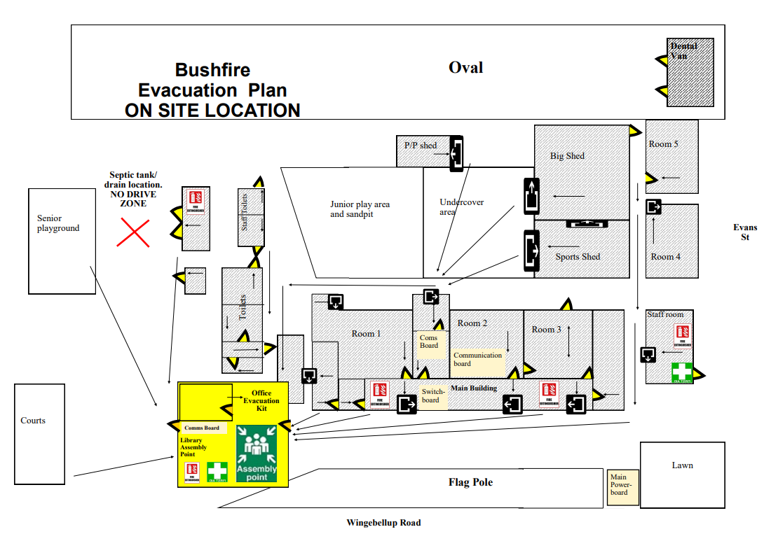 | Emergency, dial 000  Primary action:  Determine if the bushfire is a threat to the school or site.  Monitor official sources listed in section 2.  Secondary action:  Refer to Appendix B for the procedures to relocate to onsite ‘safer building location(s).
 | BER Building (Library and Admin)
  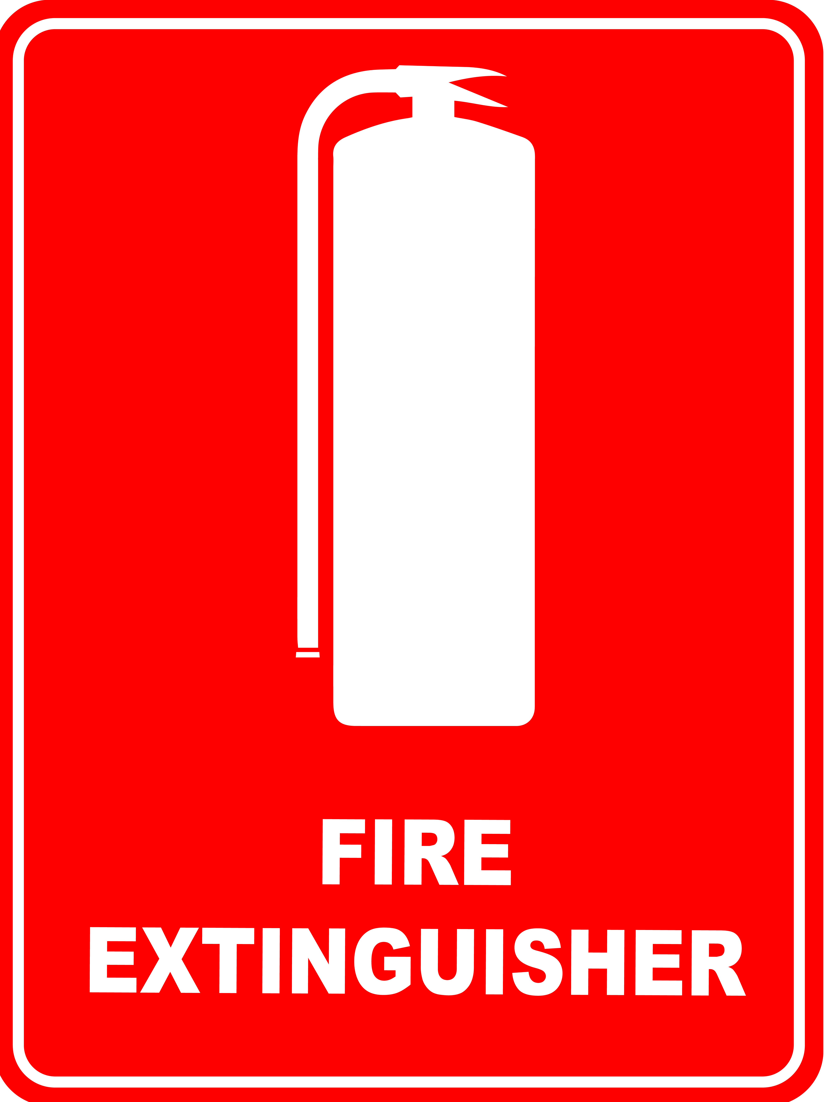       | August 2025

7.2 Offsite evacuation locations

Insert the school or site map and make sure it is marked with:
- an assembly area
- 2 offsite evacuation locations. These locations cannot be a park, reserve, oval or other open space that may expose people to heat or other conditions.
- suitable routes to access the 2 locations.

Information to help select your offsite evacuation location and a sample map is available on Ikon in Prepare for bushfire season at your school.

Safer Offsite Location 1 Frankland River Community Resource Centre  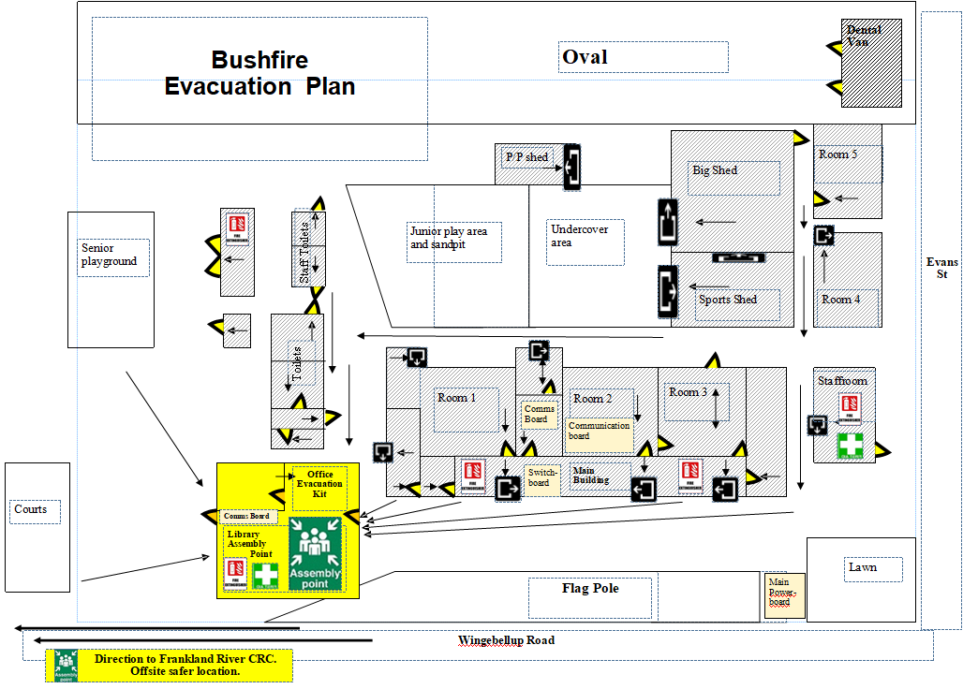  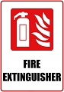        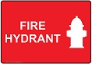 | Emergency, dial 000  Primary action:  Determine if the bushfire is a threat to the school or site.  Monitor official sources listed in section 2.  Secondary action:  Refer to Appendix B for the procedures to Relocate to an offsite evacuation location
Frankland River CRC

Map last updated: August 2025

Safer Offsite Location 2 Cranbrook Sporting Complex  *Buses will be required to transport the students  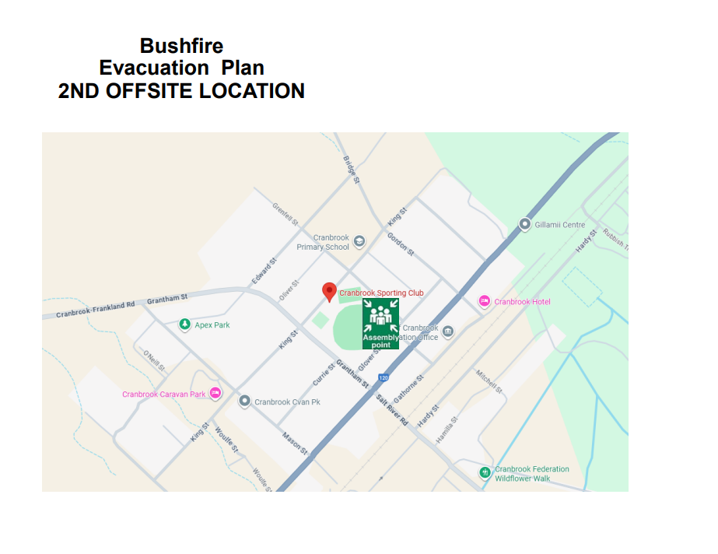 | Address:  King St Cranbrook WA 6321  Primary Action:  Contact Cranbrook Shire on 9826 1008 to notify them  Secondary Action: Cranbrook Sporting Club – Bernie Climie 0407 261 123

Appendix A - Bushfire warning stages

Emergency services communicate information in a number of ways during a bushfire event. Use these warnings to understand when your need to activate your bushfire procedures (refer to Appendix B).

Bushfire warning stages
  ADVICE | A fire is active but there is no immediate threat to lives or homes. Be aware and keep up to date.  This is general information to keep principals or site managers informed and up to date with developments.  Principals or site managers must:  - turn off evaporative air conditioners and ensure roof vents are closed.  - check and patrol the school or site regularly for bushfire activity, paying particular attention to the evaporative air conditioners.
WATCH  AND ACT   | There is a possible threat to lives or homes.Take action now to protect yourself and others.  Principals or site managers must prepare to:  - evacuate; or  - move students, staff and visitors to their pre-determined onsite ‘safer building location’. They must not be moved to an open area.  Evacuation orders are:  - issued by the Incident Controller or Emergency Services if required.  - relayed via official sources such as Emergency WA.  It is vital that the principal or site manager:  - accesses bushfire information from official sources  - makes an informed decision to stay onsite or evacuate offsite based on advice from the Incident Controller or Emergency Services.
  EMERGENCY | There is a threat to lives and homes. You may be in danger and need to take immediate action.  The principal or site manager will be advised whether staff, students and visitors can leave the area or if they must shelter where they are as the fire burns through the area.  A siren, called the State Emergency Warning Signal (SEWS), may accompany an emergency warning.  Evacuation orders are:  - directed by the Incident Controller or Emergency Services.  - relayed via official sources, such as Emergency WA.  It is vital that the principal:  - accesses bushfire information from official sources  - makes an informed decision to stay onsite or evacuate offsite based on the advice.

Appendix B - Procedures in the event of a sudden bushfire

Relocate to onsite ‘safer building location’

The principal or site manager may enact this standalone bushfire plan including relocating to the onsite safer building location as deemed necessary, or upon the advice of the Incident Controller, emergency services, Director of Education, Security and Emergency Management or Incident Support Unit.

When sheltering in place do not use an open area such as a school oval or non-enclosed building.

Initiate this procedure if any of the following occurs:
- a ‘Watch and Act’ or ‘Emergency Warning’ alert is issued for an area including the school site on the Emergency WA website (refer to Appendix A for details about the alerts).
- instruction is received from the Incident Controller, emergency services, Director of Education, Security and Emergency Management or Incident Support Unit..
- any other conditions (eg. smoke or ember attack) where the principal or site manager deem it necessary to initiate this procedure.

Follow these procedures to relocate to the onsite safer building location(s).

Action | Notes (if required)
Dial 000 for emergency services and request fire brigade.

When connected to Department of Fire and Emergency Services, advise:
- your school or site name and address
- the fire situation
- how many students and staff are being impacted
- if moving to a ‘safer building location’ and where it is located
- if anyone requires medical attention
- CB radio channel, if being used.
- Remain in contact with the Department of Fire and Emergency Services.

Monitor official bushfire emergency information contact sources in section 2.1.

Activate your school or site response team to carry out their responsibilities (section 3).

Use your emergency response contact list to contact stakeholders (section 2).

Follow your bushfire response telephone call tree (section 4) to communicate with the community.

Ensure parents receive emergency text message alerts to:
- inform them of relocation
- keep them updated (use the emergency text message alert templates, refer to Manage bushfire incident communications on Ikon).

Parents must not collect students until instructed.

Confirm:
- evaporative air conditioners are turned off
- all building roof vents, windows and doors are closed before anyone enters the onsite safer building location(s).
- where possible and safe to do so, relocate vehicles or other combustible items (school bags, rubbish bins etc) at least 20 metres from safer building locations.
- monitor embers for possible ignition.

Take emergency equipment (section 5):
- registers for students, staff and visitors
- evacuation kit
- water
- mobile phones (charged)
- student medication

Sound the school or site emergency warning or alert system.

The principal/site manager to liaise directly with emergency services to assess risk levels and confirm a safe alternative location for shelter or evacuation.

If emergency services cannot be, for example no phone or internet services, then relocate students to the best solid structure – look for a solid brick or stone building with multiple entry and exits, minimal ember entry points and as much clearance from vegetation as possible.

Students and staff must remain in classrooms or rooms unless they are directed to move to an onsite safer building location.

Check student, staff and visitor registers after moving to an onsite safer building location (roll call). Advise the police if anyone is missing.

You must give special consideration to students with known respiratory conditions.

Wait for emergency services to arrive or the incident controller to provide you with information.

Ongoing advice will also be provided by the Manager, Security and Emergency Management or the director of education.

Continue to monitor official bushfire information sources listed in section 2.1.

The Department will consult the incident controller or emergency services and notify you when it is safe to return to classrooms or for students to be collected by parents. You will receive advice from the director of education.

Offsite evacuation procedures

You may be instructed to relocate to your offsite evacuation location.

The principal or site manager must act on the official advice received from the Incident Controller, emergency services, director of education, Security and Emergency Management or Incident Support Unit, which includes remaining on site and preparing for possible evacuation.

Offsite evacuation procedures should be initiated under direction from either:
- the Incident Controller
OR
- the director of education

Follow these procedures if you need to evacuate to an offsite evacuation location during a bushfire event.

Action | Notes (if required)
Dial 000 for emergency services and request fire brigade.

When connected to Department of Fire and Emergency Services, advise:
- your school or site name and address
- the fire situation
- how many students and staff are being impacted
- if moving to a ‘safer building location’ and where it is located
- if anyone requires medical attention
- CB radio channel, if being used.

Remain in contact with Department of Fire and Emergency Services and your director of education.

Monitor official bushfire emergency information contact sources listed in section 2.1.

Activate your School or site response team to carry out their responsibilities (section 3).

Refer to the Emergency response contact list to contact stakeholders (section 2).

Follow advice from the incident controller, emergency services or the Manager, Security and Emergency Management, director of education or Incident Support Unit to decide which of the school or site’s offsite evacuation location(s) is the safest to use (section 7.2).

If safe to do so, muster at the identified assembly area where staff, students and visitors can gather to prepare for offsite evacuation.

Use an alternative assembly area if your first identified assembly area is unsafe.

Note: Students and staff must remain in classrooms or rooms unless they are directed to move to an onsite safer building location and/or onsite assembly area.

Follow the Bushfire response telephone call tree to communicate with the community (section 4).

Ensure parents and carers receive emergency SMS alerts to:
- inform them of relocation
- keep them updated (use the emergency text message alert templates, refer to Manage bushfire incident communications on Ikon).

Note: Parents must not collect students until instructed.

Confirm:
- evaporative air conditioners are turned off
- building roof vents and doors are closed.

Take emergency equipment (section 5):
- registers for students, staff and visitors
- evacuation kit
- mobile phones (charged).
- student medication.

Sound the school or site emergency warning or alert system.

- Notify bus operators
- Notify other contractors scheduled to visit the site
- Move all students, staff and visitors from the assembly area to the offsite evacuation location.

Check registers after evacuating staff, students and visitors (roll call). Advise the police if anyone is missing.

The Manager, Security and Emergency Management or the director of education will provide ongoing advice.
Continue to monitor official bushfire information sources listed in section 2.1.

The Incident Controller, emergency services or the Manager, Security and Emergency Management or Incident Support Unit will notify the director of education when it is safe to return to classrooms or for students to be collected by parents. You will receive advice from the director of education.

Appendix C - Pre-emptive (planned) school closure procedures

You may be instructed to pre-emptively close your school due to a fire behaviour index of 75 (extreme fire danger) or greater being forecast.

Note: Residential and agricultural colleges remain open when a forecast of a fire behaviour index of 75 (extreme fire danger rating) or greater is issued. These sites must have procedures in place to:
- monitor conditions
- move to the onsite safer building location, if there is any sign of a bushfire
- action an offsite evacuation, on advice from the emergency services.

Schools must initiate the closure procedures below if they receive advice from the director of education or the Security and Emergency Management unit.

Action | Notes (if required)
Monitor official bushfire emergency information contact sources listed in section 2.1.
Activate your School response team to carry out their responsibilities (section 3).
Communicate the pre-emptive closure, continued closure or school or site reopening:
- use your Emergency response contact list to contact stakeholders (section 2)
- use your Bushfire response telephone tree (section 4)
- use communication templates in Manage bushfire incident communications for SMS, social media posts and Connect notices to keep your community informed
- place the notice of temporary closure on external school or site access points and on the school website.

Note: Contact lists for staff, parents and carers must be current.
Confirm:
- windows and doors are closed
- evaporative air conditioners are turned off
- roof vents closed
- money is removed from the school premises
- expensive items of equipment secured.
Secure school premises and activate security system.
Before departing, email AssetPlanningServices.SecurityEM@education.wa.edu.au or call 9264 4632 to confirm:
- all security systems armed
- site is secure.
When the pre-emptive closure is cancelled, remove the notice of temporary closure from external school access points.

Refer to the following Flow chart – Principal’s pre-emptive school closure response.

Flow chart – Principal’s pre-emptive school closure response
Delegated officer invokes pre-closure prior to 4:30
Director of Education notifies the principal to
prepare for pre-emptive closure.
Principal follows the pre-emptive closure procedure
(refer to Standalone bushfire plan).
Fire Behaviour Index of 75 (Extreme Fire Danger) or greater forecast has been declared.

Principal notifies the school community the closure will not go ahead – school will open as normal.
Deputy Director General Schools and Manager, Security and Emergency Management decide if a school is to reopen.
The Director of Education will instruct the principal.
Principal notifies the school community whether the school remains closed or reopens.
YES
NO

Appendix D – After-hours or school holiday procedures

You may be instructed to keep your school or site closed during the school holidays or after hours during a bushfire event.

Initiate the below procedure if both of the following occur:
- A ‘Watch and act’ or ‘Emergency warning’ bushfire warning alert on the Emergency WA website is invoked (refer to the bushfire warnings listed in Appendix A)
AND
- Direction received from the Deputy Director General, Schools or the Manager, Security and Emergency Management. The director of education will relay the decision to you.

Follow these procedures if a bushfire starts during the school holidays or after hours.

Action | Notes (if required)
Remain in contact with your director of education and monitor official bushfire emergency information contact sources listed in section 2.1.

Use your emergency response contact list to contact stakeholders (refer to section 2).

Follow the bushfire response telephone call tree to communicate with your community.

Send parents and carers and staff emergency text message alerts to inform them of the school or site closure. To access sample SMS text, refer to Manage bushfire incident communications.

Work with the director of education to seek alternative school or site and transport arrangements (if required).

The Department’s Media Unit and Incident Support Unit uses media outlets and Emergency WA to make public announcements of:
- the school or site closure
- temporary alternative accommodation.

The Department will consult the incident controller or emergency services and notify you when it is safe for the school or site to reopen.

You will receive advice from the director of education or the Manager, Security and Emergency Management.

Send parents, carers and staff emergency text message alerts to inform them when school or site can reopen.

